CITY OF NEW YORK

MANHATTAN COMMUNITY BOARD FOUR

330 West 42nd Street, 26th floor New York, NY 10036
tel: 212-736-4536 fax: 212-947-9512
www.ManhattanCB4.org
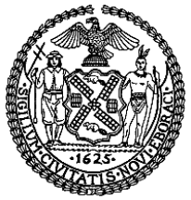
John Weis
Chair

ROBERT J. BENFATTO, JR., ESQ.
District Manager

November 12, 2009

Beverly Gotay
Assistant Director of Licensing
Department of Consumer Affairs
42 Broadway, 8th floor
New York, NY 10004

Re: Sidewalk Café Renewal

Applicant: Horseshoes NY, Inc. d/b/a Dalton’s Bar & Grill
Location: 611 9th Ave (43/44)
DCA License No.: 1190049
Type: Renewal Application – Unenclosed Sidewalk Café
Tables/Seats: 4 tables/ 8 seats

Dear Ms. Gotay:

Manhattan Community Board 4 recommends approval of the application to renew/modify the permit for an unenclosed sidewalk café submitted by the above applicant.

This was subsequent to a review of the site by the Business License & Permits Committee North and an appearance before the Committee by the applicant or a spokesperson for the applicant. No one appeared in opposition to the renewal and CB4 has no complaints on file regarding the above applicant.

We continue to request that the outer boundaries of cafes be marked on the sidewalk, as required by Department of Consumer Affair’s sidewalk café regulations.

Sincerely,
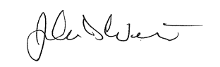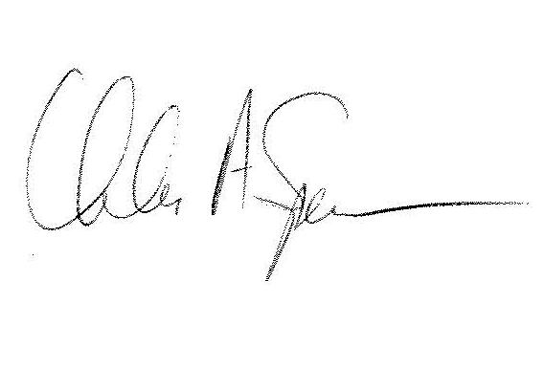
John Weiss  Chair  Manhattan Community Board 4 | John Owens  Co-Chair  Business License & Permits Committee - North | Chuck Spence  Co-Chair  Business License & Permits Committee - North

