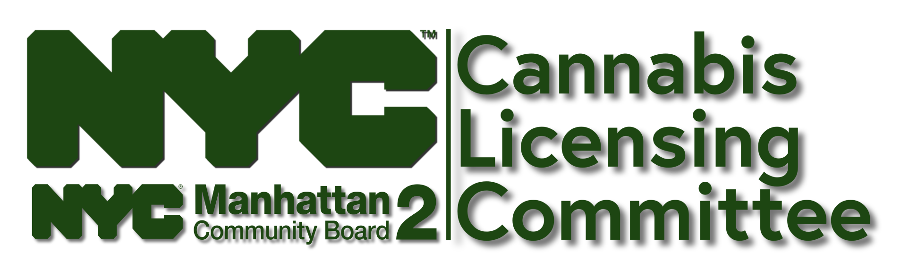

CB2 CLC Questionnaire

Proposed Premises: Lusty Flowers/Fares Alzandani 647 Broadway, 10012

Questions/Comments: https://bit.ly/ask-clc

Timestamp | 12/8/2023 8:45:30
NOTICES  How many Notification to Municipality OCM-06009 (NTM) Forms have you submitted to CB2? | 1
NYS APPLICATION TYPE | CAURD Licensee - Licensed Conditional Adult-Use Dispensary
LEGAL BUSINESS NAME & PROPOSED PREMISES  Please list the names of any and all corporate entities (i.e. LLC), and corresponding addresses for which you have submitted Municipal Notice form to CB2: (include DBA(s) if applicable) | Lusty flowers LLC  647 Broadway  New York , New York 10012
LICENSE TYPE SOUGHT: | Adult-Use Retail Dispensary
YOUR NAME: Name, email address & phone number of individual completing this questionnaire | Fares Alzandani XXXXXXXXX
REPRESENTATIVE: Name & Contact information of Applicant’s Legal Representative/Agent for Service of Process (if different than above) | N/A
AUTHORIZATION: Name of the party providing authorization Representative and that party’s relationship to the Applicant
PRINCIPAL: Principle owner's name, home address, & phone number | Fares Alzandani XXXXXXXXX Richmond Hill , New York
TRUE PARTIES OF INTEREST: Name of all individuals with financial interest in this business and percentage of ownership for each | Fares Alzandani 100%ownership
OPENING DATE: What is your projected opening date | March 2024
Social & Economic Equity Applicant Definitions  APPLICANT CATEGORY (check all that apply): | Minority-Owned Business
CAURD 1: If you participated in the Conditional Adult-Use Retail Dispensary program, please share your most recent status | N/A
PRESENTER: Name of principal representative who will present to CB2 on behalf of the business, and their relationship (i.e. applicant/self, attorney, consultant, lobbyist...) to applicant/licensee | Fares Alzandani (applicant)
LANDLORD: Property Owner/Landlord Information: Name, Phone Number, Business Address & Email Address: | Avi Dishi XXXXXXXX
PREMISES CONTROL: Please upload one of the documents listed below showing proof of the status of control over your proposed location:  a) Fully Executed Lease  b) Deed  c) Binding Letter of Intent (LOI)  d) Non-binding LOI | NONE SUBMITTED  (cover sheet for negotiation of lease term only)
INGRESS & EGRESS: Please list the addresses of all exits and entrances your business will utilize: | Between Bleecker street and Broadway Street.
CB2 INTEREST: Does any individual, group or entity with financial or operational interest in your business have a connection to Community District 2? | None
SIDEWALK STEWARDSHIP: What is the anticipated increase in sidewalk traffic? How will you manage the sidewalk, crowd control, vehicular traffic? Will you utilize stanchions and ropes? | I will manage by creating a safety, reliable mobility and healthier crowd control. I will be utilising ropes and stanchions.
PROXIMITY CHECK 1: Please list all: Retail Dispensaries within 1000 ft., Houses of Worship within 200 ft., and Schools/School Grounds within 500 ft. of your proposed premises. If none, write N/A | N/A
PROXIMITY CHECK 2: Are there any drug treatment facilities, harm reduction facilities, playgrounds or parks within 1000 ft. of the proposed cannabis business location? If yes, please list: | No
IMPACT: Please describe how you plan to handle patron noise, loitering and prevent smoking outside your establishment: | I will be having a “No smoking”policy sign only in designated areas. litter can also be picked up, provide receptacles at all entry and exits. Also provide education about the need to dispose of waste property. Also provide ash trays if needed.
STAFF: How many people will work at the address listed on your NTM form? Please list titles & positions | As much as needed to manage the business.
ADA Compliance Guides for Small Business Owners  ADA COMPLIANCE: Is your business ADA compliant? If not, what is your plan to bring it into compliance? | Yes my business is ADA compliant.
EVENTS: Will you close for private events? How many times per year? | No
SECURITY: Please describe your interior & exterior security plan: | I will be providing security cameras surrounding the business also bodyguards inside and outside of the premises.
PRODUCT PRICE LIST Please provide a list of products/services, and associated prices, to be offered at the address listed on your NTM form: | NONE SUBMITTED
ON-SITE CONSUMPTION: If this Establishment includes or plans to include on-site consumption at any point, please describe how it will be managed. What is the capacity of the consumption area? What environmental monitoring and ventilation measures will be taken to protect shoppers and staff from second hand smoke and other potential hazards? If not, please write n/a. | I will be providing air filter to prevent secondhand smoke and also have smoke hazards surrounding the premises.
DELIVERY: Will the dispensary offer delivery? | No
DELIVERY PLAN: If the dispensary offers delivery, briefly describe your delivery structure. How will you prevent delivery staff/messengers from congregating in front of the store or parking/riding bikes on the sidewalk? | N/A
PREMISES CATEGORY: What type of building is the proposed location? Please check all that apply. | OFFICE W/ COMMERCIAL - 1 TO 6 STORIES
FACADE: Will you be making any changes to the building facade? If yes, please describe the changes: | No
Discover NYC Landmarks  LANDMARK DISTRICT: Much of CB2 is a Historic District, and many of its buildings have landmark status. What is your proposed location's landmark designation? | My premises is a landmark.
OUTDOOR SPACE: Whether or not your business will utilize outdoor space, does your proposed premises allow access to any? | No
OUTDOOR OPERATIONS: If applicable, please describe how your business will use outdoor space: | N/A
HOURS OF OPERATION: What are your proposed Hours of Operation (each day of the week)? | Monday —Sunday  Hours of operation 8:00am — 12:00 pm
SOUND ATTENUATION 1: Will any amplified sounds from computers, monitors, televisions or speakers be at "background" volume at all times, and inaudible to neighboring residents and businesses at all times? | Yes
COMMUNITY ENGAGEMENT  Please describe your community outreach efforts and include the names of community groups, neighboring businesses, nearby schools, harm-reduction facilities, parks, playgrounds - and any other stakeholders you've contacted: | N/A
CO-TENANTS  If your business is located in, or congruent with a residential building(s) or commercial business(es), please describe your outreach efforts to these neighbors: | N/A
PUBLIC BENEFIT  How will your business be of benefit to the surrounding community? | I will be providing local job growth and job opportunities and positive terms of healthy and happy customers.
ADVERTISING  How will you advertise your business? | Creating an Instagram account for the business, a Google account, and Facebook advertising.
PREMISES CAPACITY/AUTHORIZED USE  Please upload a Certificate of Occupancy &/or Letter of No Objection | NONE SUBMITTED  (one-sheet with premises square footage)
INCORPORATION  Please provide proof that you are authorized to conduct business in NYS (State Dept. Letter, Articles of Incorporation, EIN letter...) | IEN RECEIPT SUBMITTED
CANNABIS SECTOR  Does any individual, group or entity with financial or operational interest in this business have interest in or connection with any other cannabis business(es) anywhere in the world? | No
CANNABIS SECTOR  Does any individual, group or entity with financial or operational interest in this business have any interest in or connection with another cannabis business under consideration by CB2 Manhattan? | No
OUT OF DISTRICT NOTICE  Have you submitted NTM form(s) to a NYC Community Board other than CB2 Manhattan? | No
SMOKE SHOP  Have you ever owned, operated or managed a shop selling cannabis, hemp, CBD, tobacco products, vapes, or ancillary paraphernalia for the purpose of smoking? | No
Please upload: The Site Plan/Floor Plan for your business: | NONE SUBMITTED
Please upload photos of: Interior/Exterior Site & Design Renderings: | NONE SUBMITTED
Please upload: Your product menu & price list: | NONE SUBMITTED
Please upload: Letters of support and/or petitions: | NONE SUBMITTED
RSVP for 12/12/23 CB2 CLC Hearing  Who will present this application before the CB2 Cannabis Licensing Committee on Tues. Dec. 12, 2023? Please list the names of all parties that will be in attendance. | Fares Alzandani
APPLICANT CATEGORY 2  Please review the ADULT-USE SOCIAL & ECONOMIC EQUITY APPLICANT OVERVIEW | N/A
WITHDRAWAL  Do you wish to, for any reason, withdraw your Notification to Municipality from consideration by CB2 Manhattan? | No
PREMISES SIZE  How many floors/levels of this premises will your business utilize? What is the square footage of each floor? | 1st floor on ground level. It is 1700 square feet.
SOUND ATTENUATION 2  Have you installed soundproofing? | We will install soundproofing
CAURD 2: If you were granted a CAURD license, please share your license date & CAURD number. If none, please write "N/A" | N/A
CAURD 3: If you were granted a CAURD license, are you applying under the same corporate entity that was awarded the license? | No
Are you currently participating in a CGS Cannabis Growers Showcase? | No

